Data Warehouse & Business Intelligence



Assignment 1

Hassan Younas
21I-1788
DS-A

Question 1

Part 1
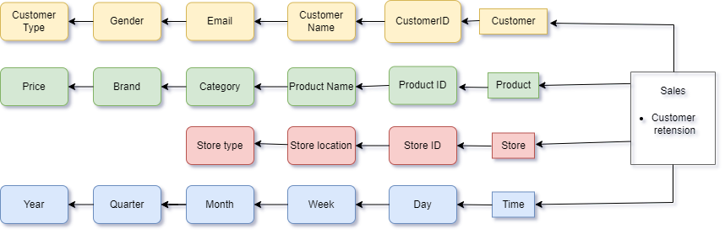

Part 2
Relational Database (RDB) is ideal for handling transactional data (e.g. orders, inventory). It organizes data into structured tables and ensures data integrity whereas Multidimensional Database (MDB) is best for OLAP operations like complex data analysis across multiple dimensions (e.g. analysing sales by region, customer segment, and time). In my opinion use combination of both RDB for transactional data management and MDB for analytical purposes. RDB would store raw sales data, and MDB would help to analyse data and increase sales. This combination will support both data integrity for day-to-day operations and high-speed analysis for business intelligence.

Part 3
Dimensions:
- Customer: To analyse preferences and satisfaction (age, gender, loyalty status).
- Product: To track the popularity of products (category, brand, price).
- Delivery: To measure delivery efficiency (delivery method, time).
- Time: To analyse trends over specific periods.

Facts:
- Customer Ratings: For measuring satisfaction levels.
- Delivery Times: For analyzing delivery efficiency.
- Returns: For identifying dissatisfaction points.
- Sales: For measuring overall performance.
These insights provide GreenGadget with actionable data to address key areas impacting customer satisfaction and delivery efficiency. By analysing customer ratings, GreenGadget can identify areas for improvement in product quality or service, thus enhancing overall customer experience. Delivery times give insight into logistical performance, allowing the company to optimize routes or partners to speed up deliveries, directly boosting customer satisfaction. Return rates can highlight product issues, enabling product improvements or more accurate descriptions. Sales trends over time help GreenGadget forecast demand, improve inventory management, and tailor marketing efforts, ultimately boosting revenue and operational efficiency. Together, these insights drive customer loyalty, reduce delivery delays, and streamline operations, improving overall company performance.

Part 4
ETL (Extraction, Transformation, Loading) process is critical to building and maintaining GreenGadget’s data warehouse, ensuring that data from various sources is consistently collected, cleaned, and stored for analysis.
Extraction
Extraction involves pulling data from various sources, such as physical store systems, online sales platforms, customer service systems, and external data sources like shipping companies or customer feedback tools.
For GreenGadget:
- Data is extracted from point-of-sale systems in the 20 stores.
- Online sales data from the company’s e-commerce platform is included.
- Additional customer interactions such as email marketing, social media feedback, and surveys.
- Inventory and supply chain data from warehouses.

Transformation
Transformation involves cleaning, converting, and structuring the extracted data into a format suitable for analysis. This step ensures that data from various sources is standardized, free of errors, and prepared for loading into the data warehouse.
For GreenGadget:
- Data Cleaning: Removing duplicates, handling missing values, and ensuring consistent formats (e.g., date formats).
- Standardization: Data from physical stores may be in different formats than online sales. For example, product IDs in stores might be different from those used online, so a standard mapping is needed.
- Calculations & Enrichments: For instance, adding calculated fields like “Customer Lifetime Value” or “Average Delivery Time” to enhance analysis.
- Data Integration: Linking data from different sources (e.g., sales transactions with customer feedback or delivery times).
- Handling Unstructured Data: If GreenGadget collects customer reviews or feedback, natural language processing (NLP) techniques can be applied to convert unstructured text into structured insights (e.g., sentiment scores).

Loading
Loading is the process of transferring the transformed data into the data warehouse, where it is organized for efficient querying and analysis.
For GreenGadget:
- Data Warehouse Setup: A well-structured data warehouse is built, often using a star or MER, where fact tables (e.g., sales data) are surrounded by dimension tables (e.g., customers, products, stores, and time).
- Batch Loading vs. Real-Time Loading: GreenGadget can opt for daily batch loads for historical data or real-time data streaming for more immediate decision-making (e.g., tracking real-time sales or delivery statuses).
- Data Partitioning: Data can be partitioned based on time (e.g., monthly sales) to optimize query performance.
- Indexes & Aggregations: Creating indexes for frequently queried columns (e.g., product ID, customer ID) and pre-computed aggregates (e.g., total sales by month) to speed up analysis.

Question 2

Part 1:
- Customer: Data about customers, their preferences, and stay history.
- Bill: Transaction details for every service provided to the customer (e.g., room charges, restaurant bills).
- Order: Information on orders placed in the hotel's restaurant, including items, quantity, and payment.

Part 2:
- Order Fact Table:
  - Attributes: Order ID, Customer ID, Date, Item ID, Quantity, Price, Total Amount.
- Bill Fact Table:
  - Attributes: Bill ID, Customer ID, Bill Date, Total Amount, Payment Method.
- Reservation Fact Table:
  - Attributes: Reservation ID, Customer ID, Room ID, Check-In Date, Check-Out Date, Total Cost.

Part 3:
- Customer:
  - Attributes: Customer ID, Name, Address, Contact Number, Loyalty Status.
- Item:
  - Attributes: Item ID, Item Name, Description, Category, Price.
- Time:
  - Attributes: Date, Day, Month, Quarter, Year.
- Room:
  - Attributes: Room ID, Room Type, Room Rate, Occupancy Status.
Part 4:
- Occupancy Rate: Measures how often rooms are booked. This helps in understanding room demand and improving booking strategies.
- Average Customer Spend: Tracks the total spend per customer, helping to analyse customer value and target high-spending guests.
These measures and models provide insight into operational performance and customer behaviour, helping the hotel to optimize services and profitability.

Question 3

2-Tier Architecture of a Data Warehouse:

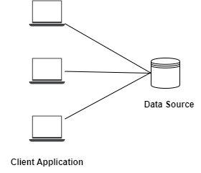

Tier 1: Client Layer (User Interface)
Users access data directly from the data warehouse using query tools, dashboards, or reporting systems.
Tier 2: Data Warehouse Layer (Server)
The data warehouse holds all the collected and processed data, allowing users to retrieve information directly.
In this architecture, the client directly connects to the data warehouse server, bypassing any middleware. It's simple but not scalable for larger systems. Typically, it's used in smaller environments where fewer users and queries are executed.

3-Tier Architecture of a Data Warehouse:

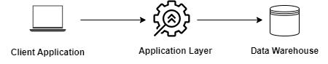
Tier 1: Client Layer
Users interact with the system via reporting, querying, and analysis tools.
Tier 2: Application Server (Middle Tier)
A middleware layer processes requests from the client, performs transformations, and sends the queries to the data warehouse.
Tier 3: Data Warehouse Layer
The actual storage and retrieval of data occur here.
The Client Tier enables users to request data. The Application Tier processes these requests, applying any necessary transformations or calculations. The Data Warehouse Tier stores, organizes, and retrieves the required data. This is the most commonly used architecture, offering better scalability and efficiency than the 2-tier model.

5-Tier Architecture of a Data Warehouse:
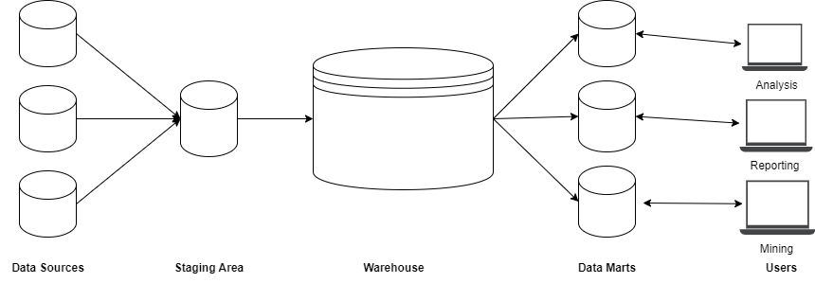

Tier 1: Data Sources
Data is extracted from different sources like transactional databases, web data, etc.
Tier 2: ETL (Extraction, Transformation, Loading)
Data is cleansed, transformed, and loaded into the data warehouse.
Tier 3: Data Warehouse
Stores the integrated, cleansed, and historical data.
Tier 4: OLAP Server
Provides the tools for multidimensional data analysis and fast querying.
Tier 5: Client Layer (User Interface)
The end-user interface where reports, dashboards, and analytics are accessed.

- Data Sources provide raw data from various platforms.
- ETL handles data cleansing and loading.
- Data Warehouse is the central repository for storing all structured data.
- OLAP Server allows users to perform fast, complex queries and multidimensional analysis.
- Client Layer gives users access to processed and analysed data, helping in decision-making.
The 5-tier architecture provides better scalability, data quality, and flexibility in terms of reporting and analysis compared to simpler architectures.

Question 4

Part 1:
Setting Up Data Storage for Multiple Regions:
  - A distributed data warehouse design is ideal since FreshHarvest operates across multiple regions. Each region can have its local data storage (regional data marts), and these can be integrated into a central data warehouse.
  - Data from regional branches can be loaded into the local data marts, which are then synchronized with the central data warehouse for global analysis.
  - This setup ensures regional insights are quickly accessible while allowing global analysis.
Region-Specific Details in Data Storage:
  - Agricultural Conditions: Different regions have varied weather conditions and storage capacity.
  - Market Demands: Consumer preferences differ across regions, which might require different storage schema designs to capture region-specific product sales and supply chain data.
  - Currency and Language: Each region may use different currencies and languages, which should be considered for localized reporting and business analysis.
Part 2:
The best approach for collecting data would be using ETL (Extraction, Transformation, Loading) tools. These tools can extract data from diverse sources, clean and format it to a standard format, and load it into the data warehouse. I’m choosing ETL because it ensures data consistency and allows data from different systems (regional databases, external APIs, etc.) to be merged into a unified format.
Problems:
- Inconsistent Data Formats: Different regions may store data in varied formats (e.g., date formats). Solution: Apply data transformation rules during ETL.
- Data Duplication: Multiple regions might create redundant records. Solution: De-duplicate data during loading using unique identifiers.
- Latency in Data Synchronization: Delays in updating the central warehouse with regional data could cause inconsistencies. Solution: Implement real-time or near-real-time synchronization.
- Missing Data: Some regions may have incomplete records. Solution: Apply data validation checks and fill gaps with standardized default values.
- Cultural and Language Differences: Regions may use different terms for the same product. Solution: Create a metadata dictionary to standardize product names and categories.
Part 3:
The best time to perform bulk data loading would be off-peak hours, such as late nights or weekends, when system usage is minimal. This minimizes system performance issues and ensures that loading large volumes of data doesn’t affect regular business operations.

Part 4:
  - Which region yields the highest profit margins?
  - What is the impact of weather conditions on crop yields in each region?
  - How do consumer preferences vary across different regions?
  - What are the most efficient supply chain routes to minimize delivery times?
  - Which products have the highest return rates, and why?
These insights would help FreshHarvest optimize operations, tailor products to market demands, and improve supply chain and profitability strategies across different regions.

